

**Complex Commercial SATCOM Solutions (CS3)**

***CS3 Customer Ordering Guide***

*Version 1.4*

**July 2020**

**DOCUMENT CHANGE RECORD**

|  |  |  |
| --- | --- | --- |
| **Version Number** | **Date** | **Description** |
| 1.0 | 10/24/2017 | Initial release |
| 1.1 | 11/9/2017 | Updated to reflect addition of new contractors |
| 1.2 | 3/22/2018 | Added new contact information for contractors |
| 1.3 | 12/12/2019 | Updates to Appendix B and Appendix C |
| 1.4 | TBD | Add GSA Task-Order and Delivery Order Ombudsman guidance |

**Table of Contents**

Contents

1 Introduction 1

1.1 Contract Objectives 2

1.2 Contract Scope 3

1.3 Contract Benefits 3

2 Purpose and Scope 4

2.1 Guide Layout 4

3 Contract General Guidance 5

3.1 Term of Contract 5

3.2 Ordering Guidelines 5

3.3 Task Order Period of Performance 6

3.4 Authorized Contract Users 7

3.5 GSA Management Fee 7

4 Ordering Process 8

4.1 Roles and Responsibilities 8

4.2 Ordering Processes 10

4.2.1 High-Level CS3 Ordering Process 10

4.2.2 Delegated Procurement Authority (DPA) Process 10

4.2.3 Statement of Work/Performance Work Statement (SOW/PWS) Review Process 11

5 Ordering and Billing Options 12

5.1 Direct Order/Direct Bill 12

5.2 GSA Assisted Ordering/Billing 14

5.3 eBuy 14

APPENDICES 1

Appendix A. Task Order Administration 1

1.1 User Reporting Requirements 1

1.1.1 Contractor Performance 1

1.2 Claiming Socioeconomic Credit in the Federal Procurement Data System – FPDS NG Reporting 2

1.3 Contract Modification 2

1.4 Task Order (Contract) Closeout 2

Appendix B. GSA CS3 Point of Contacts 3

Appendix C. List of CS3 Contractors 4

Appendix D. List of Abbreviations 5

# 1 Introduction

The General Services Administration (GSA) and Defense Information Systems Agency (DISA) partnered in 2009 to sign the Memorandum of Agreement (MOA) for Future COMSATCOM Services Acquisition (FCSA). Under the FCSA umbrella, the Custom SATCOM Solutions (CS2) and Custom SATCOM Solutions – Small Business (CS2-SB) contracts were awarded in 2012 to more strategically source the acquisition of commercial satellite communications and to reduce overall acquisition program costs.

As CS2 and CS2-SB approached expiration, GSA and DISA exercised their option within the MOA to formulate the successor vehicle, Complex Commercial SATCOM Solutions (CS3). Lessons learned from previous CS2 and CS2-SB programs helped shape the new contract under the FCSA Program.

The CS3 program offers customers a wide range of benefits:

* **Improved responsiveness** to task order requirements
* **Cost savings** due to a reduction in the time and resources involved in the procurement process
* **Increased contractor competition** to encourage more responsive pricing, higher levels of service quality, and increased system availability
* **Expanded role for small businesses** to receive the maximum level of satellite systems business consistent with quality performance and value for government buyers
* **Enhanced contract flexibility** with a ten-year period of performance
* **Leveraged buying power** as a single source for satellite services acquisition across the Federal Government

CS3 is a multiple-award, Indefinite Delivery, Indefinite Quantity (IDIQ) firm fixed-price contract; all task orders issued against this contract will be firm fixed price.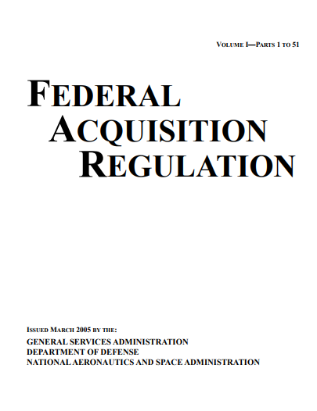 Under CS3, a task order is the official contractual mechanism to be used by agencies to order COMSATCOM services and ancillary products or services. All task orders are subject to *fair opportunity* as defined in [Federal Acquisition Regulation (FAR) 16.505](https://www.acquisition.gov/?q=/browse/far/16): the FAR requires all awardees under a multiple award contract be given a fair opportunity to be considered for each task order in excess of $3,500, unless an exception applies.

## 1.1 Contract Objectives

The overarching objective for CS3 is to create contracts as flexible and agile as possible to meet and satisfy the widely differing requirements of federal organizations at present, for the next decade, and for the period beyond. CS3 is intended to meet program goals for the following:

|  |  |
| --- | --- |
| * Service continuity | * Operations support |
| * Highly competitive prices | * Transition assistance and support |
| * High-quality service | * Opportunities for technical innovation |
| * Full service contractors |  |

The CS3 vehicle provides worldwide customized COMSATCOM solutions for complex commercial satellite requirements for government agencies and other authorized entities. Two main roles:

* **Government agencies:** define the requirements for satellite services
* **Contractors:** engineer custom solutions

The customized COMSATCOM solutions comprise complete, customized engineered-solutions to meet customers’ unique commercial satellite needs. These solutions may include any combination of the following: fixed, mobile, or broadcast satellite services, components, and service enabling authorizations (e.g., host nation approvals, landing rights, frequency clearances, etc.), along with components and ancillary equipment such as terminals, teleports, terrestrial tail circuits, Subscriber Identity Module (SIM) cards, and peripherals.

Complex Commercial SATCOM Solutions may include, but are not limited to design; development; licensing; integration; installation; testing; network management; engineering; full lifecycle logistics; and operations support and training. Delivered solutions may be turnkey systems comprising all elements of a system or may be limited to integration of specific components along with existing government-provided elements.

## 1.2 Contract Scope

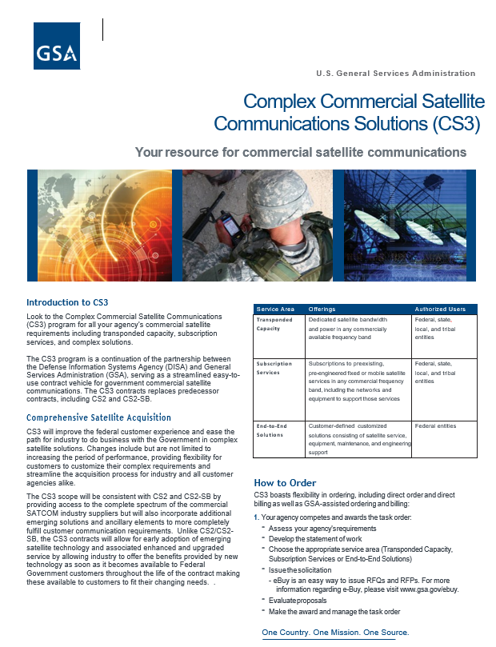As with the previous CS2 and CS2-SB contracts, CS3 is an agency-unique acquisition solution whose scope provides access to the complete spectrum of the COMSATCOM industry suppliers and integrators to support a wide range of complex requirements. CS3 incorporates additional innovative solutions and ancillary elements to fulfill customer complex communications requirements and allows for early adoption of emerging satellite technology and associated enhanced and upgraded services by allowing industry to offer the benefits provided by new technology as soon as it becomes available.

The CS3 scope includes any combination of fixed satellite services and/or mobile satellite services, components, service enabling authorizations (e.g., host nation approvals, landing rights, frequency clearances, etc.) and components and ancillary equipment such as terminals, teleports, terrestrial tail circuits, Subscriber Identity Module (SIM) cards, and peripherals.

Complex solutions under CS3 may include, but are not limited to, design, development, licensing, integration, installation, testing, network management, engineering, full lifecycle logistics and operations support, and training. Delivered solutions may be turnkey systems comprising all elements of a system, or delivered solutions may be limited to integration of specific components with existing Government-provided elements.

**Stand-Alone Satellite Professional Support Services [RESERVED FOR SMALL BUSINESSES ONLY]**:

Additionally, CS3 provides for the ability to order Stand-alone Satellite Professional Support Services. These services MUST be set-aside for small businesses if ordered and include, but are not limited to, abstract or concept studies and analysis, strategic and preliminary planning, requirements definition and analysis, evaluation of alternative technical approaches, modeling and simulation, enterprise architecture design, cost-performance trade-off analysis, feasibility analysis, regulatory compliance support, system engineering, independent verification and validation, network performance assessment, and, and Information Assurance Security Assessment and Security Authorization.

## 1.3 Contract Benefits

CS3 provide several benefits to participating government agencies:

* **Service Continuity:** Encompasses various satellite requirements, level of complexity, and satellite applications solutions
* **Enhancing Acquisition Efficiency:** Offers easy access to leading satellite technologies aligned with government parameters, interfaces, and standards
* **Delivering Better Value and Savings:** Delivers cost savings during implementation, transition, and ongoing operations of COMSATCOM services
* **Leading with Innovation:** Allows for early adoption of emerging satellite technology and associated enhanced and upgraded services
* **Expanding Opportunities for Small Business:** Includes an open season to add additional small businesses to the contract to ensure there be adequate small business completion throughout the life of the contract
* **Highly Competitive Pricing:** Offers equipment and services at equal to or less than commercial prices
* **Continuous Competition:** Provides agencies with a broad array of competitive service options
* **Full Range of Commercial Offerings:** Provides a wide range of commercial satellite offerings to include mobile, fixed, and broadcast solutions; allows for incorporation of new innovative technologies and solutions without the need of contract modification[1]
* **Flexible Ordering and Billing Options:** Allows ordering and billing options for customers to take advantage of Direct Order/Direct Bill or GSA Assisted Ordering and Billing options
* **Service Quality:** Offers high quality of service
* **Information Assurance:** Ensures solutions meet government information assurance and protection requirements

# 2 Purpose and Scope

GSA’s Office of Telecommunications Services (OTS) developed this *Customer Ordering Guide* for Ordering Contracting Officers (OCOs) and other stakeholders to facilitate the use of GSA’s CS3 vehicle in order to ensure a successful, timely, and orderly transition of services from expiring legacy contracts, CS2 and CS2-SB, as well as, placing new orders on the contract. It also serves to inform and acquaint all agencies with the proper use of CS3.

This Guide provides guidelines and ordering process for satellite services under CS3 service providers. It defines the roles and responsibilities of GSA and the ordering agency. More information regarding the below CS3 partners and updates is available on the GSA Satellite Services website at <http://www.gsa.gov/satellite>. The guidance provided here does not supersede requirements of the FAR or agency FAR supplements and policies.

## 2.1 Guide Layout

The remainder of this Guide provides general contract guidance then focuses on the ordering process. It is divided into the following sections:

* Contract General Guidance (Section 3)
  + Term of Contract
  + Ordering Guidelines
  + Task Order Period of Performance
  + Authorized Contract Users
  + GSA Management Fee
* Ordering Process (Section 4)
  + Roles and Responsibilities
  + High-Level CS3 Ordering Process
  + Delegation of Procurement Authority (DPA) Process
  + Statement of Work/Performance Work Statement (SOW/PWS) Review Process
* Ordering and Billing Options (Section 5)

# 3 Contract General Guidance

## 3.1 Term of Contract

CS3 contracts are not Federal Supply Schedules or Government-Wide Acquisition Contracts (GWACs); therefore, the guidelines and rules for using these contracts differ from those for Schedules and GWACs.

The contract period of performance (PoP) consists of one (1) five-year base period plus one (1) three-year option period and one (1) two-year option period (Ordering Period of Performance). The government may unilaterally exercise the option periods.

The CS3 PoP is as follows:

* **Base period:** 10/16/2017 through 10/15/2022
* **Option period 1:** 10/16/2022 through 10/15/2025
* **Option period 2:** 10/16/2025 through 10/15/2027

**Minimum Order Value:** None

**Maximum Order Value:** The cumulative amount of all task orders combined—including all options—cannot exceed the program ceiling amount of $2.5B.

## 3.2 Ordering Guidelines

All stand-alone Satellite Professional Support Services must be ordered from a small business.

Redacted versions of the CS3 contracts, which include contract period pricing, are available for viewing and download from each contractor’s website. Some contractors may require registration before allowing access, and links to each contract are provided via the contractor’s link located at <http://www.gsa.gov/satellite>.

* **Order Type**—Orders under the basic contract will be firm fixed price. Orders must be task orders in compliance with FAR 16.505. Task orders may be multi-year and/or include options as defined in FAR Part 17 and agency-specific FAR Part 17 supplements. The OCO must use performance-based acquisition methods to the maximum extent practicable
* **Order Pricing**—The OCO is responsible for the determination of reasonable price for each order placed under CS3. The OCO must determine fair and reasonable pricing for all orders in accordance with FAR Subpart 15.4—Contract Pricing—and FAR 16.202—Firm-fixed-price contracts
* **Travel**—A task order may require travel which will be identified in the task order. All travel shall be accordance with the Federal Travel Regulations (FTR)/Joint Travel Regulations (JTR)

## 3.3 Task Order Period of Performance

The term for each order placed under the Basic Contract shall be specified in the Individual Order. Under no circumstances may an order be placed under the Basic Contract if the Basic Contract has expired, been terminated, or cancelled by the government. Based upon the schedule above, the base period expires October 15, 2022. If all options are exercised, the Basic Contract will expire on October 15, 2027. (See FAR 52.216-18, 52.216-19 and 52.216-22.) Task order performance can be performed up to October 15, 2032, which is past the basic contract expiration date, only when (1) orders are issued before October 15, 2027; and (2) options are included at the initial issuance of the order. The FAR Clause 52.217–8 Option to Extend Services ***cannot*** be used to extend work past October 15, 2032.

Accordingly, the cumulative term of CS3 Basic Contract may span up to 10 years. No individual task order may exceed 10 years, inclusive of options, from the date the task order is placed; the cumulative term of all task orders placed under CS3 may span up to 15 years.

***For Example*:**

If a task order is placed on October 15, 2027 for 5 years (one-year base period with four one-year option periods), the task order PoP would look like this:

* One-Year Base Period: October 15, 2027 – October 14, 2028
* First Option Period: October 15, 2028 – October 14, 2029
* Second Option Period: October 15, 2029 – October 14, 2030
* Third Option Period: October 15, 2030 – October 14, 2031
* Forth Option Period: October 15, 2031 – October 14, 2032

After the CS3 Basic Contract term expires, CS3 will remain an active contract until the final task order is closed-out and shall govern the terms and conditions with respect to active task orders to the same extent as if they were completed during the CS3 Basic Contract term.

Notwithstanding anything contrary to the above, an ordering agency may place a multi-year task order under the CS3 Basic Contract; a task order using multi-year contracting methods must be consistent with FAR Subpart 17.1 and any applicable funding restrictions.

## 3.4 Authorized Contract Users

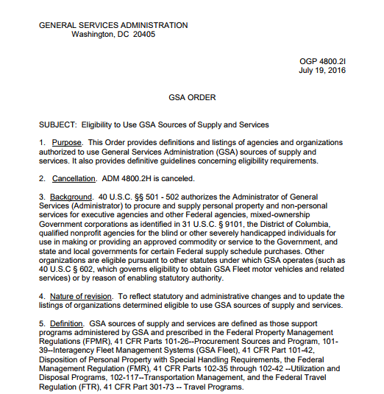Only authorized users may place orders under the Basic Contract. To become qualified as an authorized user, a duly warranted Contracting Officer (as that term is defined in FAR Subpart 2.1) in good standing must have an appropriate signed Delegation of Procurement Authority (DPA) issued from the GSA CS3 PCO. For purposes of this basic contract, these authorized users are identified as OCOs.

This Basic Contract is for use by all federal agencies, and others as listed in GSA Order ADM 4800.2I, Eligibility to Use GSA Sources of Supply and Services, July 19, 2016, which is modified from time to time.

OCOs must follow the ordering procedures of FAR 16.505, among possible others, with particular attention to the Fair Opportunity procedures specified in FAR 16.505(b)(1) and the exceptions to Fair Opportunity in FAR 16.505(b)(2). Use of the GSA eBuy system by the OCO will ensure all Basic Contract holders are notified of each task order request—eBuy is an electronic Request for Proposal (RFP) system designed to allow government buyers to request information, find sources, and prepare RFPs for CS3 contracts completely online. Information and instruction on the use of the eBuy system is furnished at [www.gsa.gov/ebuy](http://www.gsa.gov/ebuy).

**DoD Customers:**

In accordance with DoDI 8420.02, DoD Satellite Communications (SATCOM), September 15, 2016, DISA serves as the lead for acquisition of COMSATCOM services to meet the needs of DoD Components, consistent with approved user requirements and funding provided by the requesting DoD Component.

DoD customers should contact DISA for assistance in procuring COMSATCOM services. For more information, visit the DISA website at <http://www.disa.mil/Network-Services/Satellite>.

In addition, DoD customers are required to follow DoD/DISA ordering procedures; DoD end-to-end satellite requirements must be routed through DISA per DoD policy.

## 3.5 GSA Management Fee

All ordering activities are charged a 2% contract access fee which should be included in all the CS3 CLINs and ***not as a separate line item***. The CS3 contractor pays said fee when it receives invoice payments from the ordering activity. For GSA Assisted Ordering/Billing, an additional fee for this assistance is negotiated between the ordering agency and GSA; the CS3 contractor is not involved in the negotiation or collection of the GSA Assisted Service Fee.

# 4 Ordering Process

## 4.1 Roles and Responsibilities

The roles and responsibilities are broken down by the Ordering Agency, GSA, and Product / Service Provider. Note: The government may modify the roles and responsibilities at any time during the period of performance of the basic contract. See Table 1 for breakdown and descriptions.

* Ordering Agency:
  + **Government Ordering Contracting Officer (OCO) or Representative:** Order on behalf of the ordering Agency
* GSA:
  + **Program Manager (PM):** Oversee FCSA, including CS3 contract
  + **Procuring Contracting Officer (PCO):** Award contracts
  + **Administrative Contracting Officer (ACO):** Perform contract administration functions on behalf of PCO
  + **Contracting Officer’s Representative (COR):** Monitor Base Contract level deliverables
* Product / Service Provider:
  + **Contractor:** Provide product/service to ordering Agency

Table 1: Roles and Responsibilities

| Role | Responsibilities | Notes |
| --- | --- | --- |
| Government Ordering Contracting Officer (OCO) | * Obtain Delegated Approval Authority to use CS3 * Obtain scope review on CS3 requirement prior to issuance of solicitation against the CS3 vehicle * Comply with FAR 16.505 * Provide **ALL** CS3 contract holders a Fair Opportunity to be considered for each Task Order exceeding $3,500 unless: * one of the exceptions cited in FAR 16.505(b)(2) applies and there’s a fully documented and signed justification which cites the reason for using one of these exceptions, IAW FAR 16.505(b)(1) * Analyze order proposals and document evaluation to include a determination that final negotiated price is fair and reasonable, IAW FAR 16.505(b)(3) and the OCO’s agency’s requirements * Select winning contractor * Place Task Orders in accordance with FAR 16.505(a)(7) * Annual PPIRS IAW with FAR 42.15 and the OCO’s Agency’s FAR supplement * Close out a completed order by using procedures described in FAR 4.804 * Provide notification to the GSA CS3 PCO of a task order closeout immediately upon closeout | * OCOs may exercise broad discretion in developing appropriate CS3 Task Order placement procedures IAW FAR 16.505(b)(1) most notably ensuring that Price or cost elements **MUST** be one of the factors in the selection decision * Proposal documentation will remain in the OCO’s official task order file and must be provided upon request to GSA’s CS3 PCO * OCOs **MUST** set aside stand- alone Satellite Professional Support Services requirements and may set aside other requirements for CS3 small business contractors in accordance with the FAR and the OCO’s Agency’s FAR supplement * Task order may be placed immediately with the winning contractor once proposals are evaluated * Complaints regarding task and delivery order actions of other agencies using GSA contract vehicles shall be directed to the ordering agency’s Task-Order and Delivery-Order Ombudsman |
| GSA Program Manager | * Perform various programmatic functions for the overall success of the FCSA program, including CS3 | * Does not have actual, apparent, or implied authority to bind the government for any acts or omissions |
| GSA Procuring Contracting Officer (PCO) | * Has the sole and exclusive actual authority to award the basic contract * Designate a GSA CS3 COR at the Basic Contract level * Issues Delegation of Procurement Authority to OCOs | * After award of the basic contract, may delegate any or all the contract administration functions described in FAR 42.302 and may appoint an administrative contracting officer (ACO) to perform administration functions described in FAR 42.302 |
| GSA Administrative Contracting Officer (ACO) | * Perform contract administration functions on behalf of the PCO | * If functions delegated by the GSA PCO |
| GSA Contracting Officer’s Representative (COR) | * Monitor the Basic Contract level deliverables | * Specific rights and responsibilities shall be described in writing, which upon request shall be provided to the contractor * Has no actual, apparent, or implied authority to bind the government |
| Contractor | * Provide product and/or services to ordering Agency per task order requirements * Engineer custom solutions for ordering Agency as required * One must respond by cut-off date of RFP if he wishes to make a bid | * Has a right to be considered for requirements in accordance with the Fair Opportunity requirements of FAR 16.504 * Only the CS3 Prime Contractor(s) listed in the Appendix may provide a response directly to the ordering activity. Affiliates of the Prime Contractor (e.g., business partner, subsidiary or subcontractor) are not authorized to provide responses to a potential procuring agency’s request; the CS3 contract is between GSA CS3 PCO and the Prime Contractor |

In accordance with GSAM 516.505 (b): The GSA Task-Order and Delivery Order Ombudsman shall review and resolve complaints from contractors concerning all task and delivery order actions made by GSA. Complaints regarding task and delivery order actions of other agencies using GSA contract vehicles shall be directed to the ordering agency’s Task-Order and Delivery-Order Ombudsman.

For orders issued by GSA, see https://www.gsa.gov/policy-regulations/policy/acquisitionpolicy/gsa-ombudsman

GSA TASK & DELIVERY ORDER OMBUDSMAN CONTACT INFORMATION GSA Task & Delivery Order Ombudsman: 1800 F Street NW, Washington, DC. 20405. Email: gsaombudsman@gsa.gov

NOTE: guidance provided here does not supersede requirements of the FAR or agency FAR supplements and policies. In all cases, the OCO must ensure complete adherence to the CS3 contract, applicable laws, the FAR, and any additional agency policy and regulations.

## 4.2 Ordering Processes

### 4.2.1 High-Level CS3 Ordering Process

The Ordering Agency starts by submitting the Delegation of Procurement Authority (DPA) to GSA (see Figure 2 for the DPA Process). It should be noted the DPA is required for each OCO who will be soliciting or ordering services through the CS3 vehicle. Figure 1 depicts the High-Level CS3 Ordering Process.

Figure 1: High-Level CS3 Ordering Process

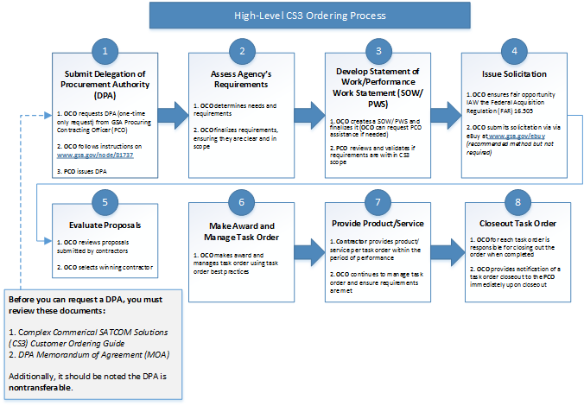

Once an OCO has a DPA, he or she will not be required to submit one again, that is, the DPA is valid for unlimited use. However, DPAs operate on a per capita basis and unique to the holder; thus, they are non-transferable from individual to individual or agency to agency.

### 4.2.2 Delegated Procurement Authority (DPA) Process

The OCO completes the online request form and submits the DPA request to the GSA PCO. The PCO reviews and provides the delegation. If an OCO moves to a different Agency, they must inform the GSA CS3 PCO immediately. A new DPA request is required that will be expedited. See Figure 2 for detailed DPA Process.

Figure 2: Delegated Procurement Authority Process

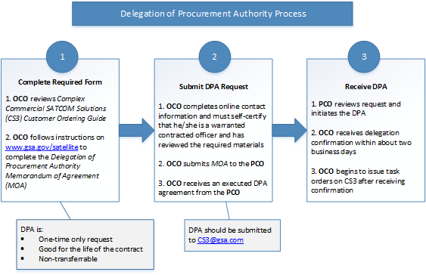

The OCO must complete and submit the online DPA request by filling in the required information and selecting the responses to the questions. The DPA should be submitted to [CS3@gsa.com](mailto:CS3@gsa.com).

### 4.2.3 Statement of Work/Performance Work Statement (SOW/PWS) Review Process

The OCO drafts the SOW/PWS and submits to GSA. If GSA deems the requirement is within the scope of CS3, an email is sent to the OCO. If the requirement is NOT within scope, the OCO is notified and the SOW/PWS is reworked. See Figure 3 for detailed SOW/PWS Review Process.

Figure 3: Statement of Work / Performance Work Statement Review Process



Note: The PWS does not include price structure or order terms.

# 5 Ordering and Billing Options

The ordering agency has two options for placing task orders:

* Direct Order/Direct Bill
* GSA Assisted Ordering/Billing

The subsequent subsections identify the required actions for each type of ordering option and offer examples.

## 5.1 Direct Order/Direct Bill

Questions about ordering/requirements should be directed to the CS3 contractors directly and go to the CS3 contractors to place orders after conducting fair opportunity in accordance with FAR 16.505. The billing and payment for these services are conducted directly between the ordering agency and the CS3 contractors. The OCO will be subject to the rules, regulations, and conditions promulgated and enforced by that customer agency, the FAR, and the CS3 contract. The ordering agency will commit the following:

* Determine requirements and develop a SOW or PWS
* Identify Information Security System requirements for Federal Information Security Management Act (FISMA) Certification and Accreditations in the SOW/PWS
* Identify Personnel Security for both suitability (HSPD-12) and security clearance requirements in the SOW/PWS
* Incorporate and provide agency-specific security directives, guides, and procedures in the SOW/PWS
* Determine if requirements are within the scope of CS3 (with assistance from GSA); the GSA CS3 PCO will provide a scope determination to the OCO
* Determine if the task order value does not exceed the cumulative CS3 program ceiling. The GSA CS3 PCO will provide a ceiling determination to the OCO
* Verify, obligate, and ensure proper use of funds
* Request interest from contractors if applicable (e.g., Request for Information [RFI])
* Document Fair Consideration method or sole source justification (the use of the GSA eBuy system is highly encouraged as it will ensure all eligible contractors can participate in the task order solicitation)
* Request proposals from contractors (e.g., Request for Proposal [RFP])
* Evaluate proposals (technical, price, or cost must be considered for each order in the selection decision)
* Select CS3 contractor
* Place task order with selected CS3 contractor
* Process task order close-out

Formal evaluation plans or rating schemes are not required; however, the evaluation and acquisition plan should match the value and complexity of the requirement. Once the ordering agency has finalized its statement of work, said agency will request information in potential addition to a proposal directly from the CS3 contractors.

A written SOW or PWS will always be used. The OCO will provide the SOW/PWS to the GSA CS3 PCO and GSA CS3 PM. The GSA will provide a scope determination to the OCO. Scope reviews can be conducted by GSA and completed in parallel with the OCO's task order acquisition activities. For task orders requiring immediate delivery of service for an urgent requirement, the GSA scope review may be completed after the task order is awarded. Should the GSA CS3 PCO determine a CS3 task order to be out of scope, the GSA CS3 PCO will inform the OCO that the task order must be canceled. The Scope Determination process is as follows:

1. Forward a copy of the written SOW or PWS to the GSA CS3 PCO at the following email address (case insensitive): [CS3@gsa.gov](mailto:CS3@gsa.gov)

Within 2 business days of receipt of the SOW/PWS, the GSA CS3 PCO will ensure that a DPA is on file for the issuing OCO and forward the SOW/PWS to GSA for review; GSA will acknowledge receipt of the Scope Determination request

1. Within 5 business days of receipt of the Scope Determination request, the OCO is notified of the results of the Scope Determination
2. If the Scope Determination is negative, the OCO is contacted to provide guidance on the appropriate scope for task orders under CS3. The OCO may be requested to prepare and reissue a revised Scope Determination request

The CS3 contractor Points of Contact (POC) is publicly accessible at <http://www.gsa.gov/satellite>.

## 5.2 GSA Assisted Ordering/Billing

Under GSA Assisted Services, GSA may perform any or all the following on behalf of an agency:

* Assist and/or develop an SOW
* Ensure fair opportunity and contractual compliance as stipulated in section G.3.3 of the contract and in accordance with the Federal Acquisition Regulation (FAR) 16.505
* Verify, obligate, and ensure proper use of funds
* Evaluate proposals and award orders
* Maintain all award documentation
* Process order closeout

The GSA Assisted Service Fee is negotiated between GSA and the ordering agency. Payment of this Assisted Service Fee is made directly to GSA by the ordering agency using:

* an Interagency Agreement (IA)
* a Memorandum of Agreement (MOA)
* a Memorandum of Understanding (MOU) with an accompanying customer funding document and GSA acceptance

These agreements are the primary means by which GSA receives requests from federal agencies for acquisition services.

GSA acceptance is required on all funding documents such as Purchase Request (PR); Intra-Governmental Payment and Collection (IPAC) systems; and Military Interdepartmental Purchase Request (MIPR).

## 5.3 eBuy

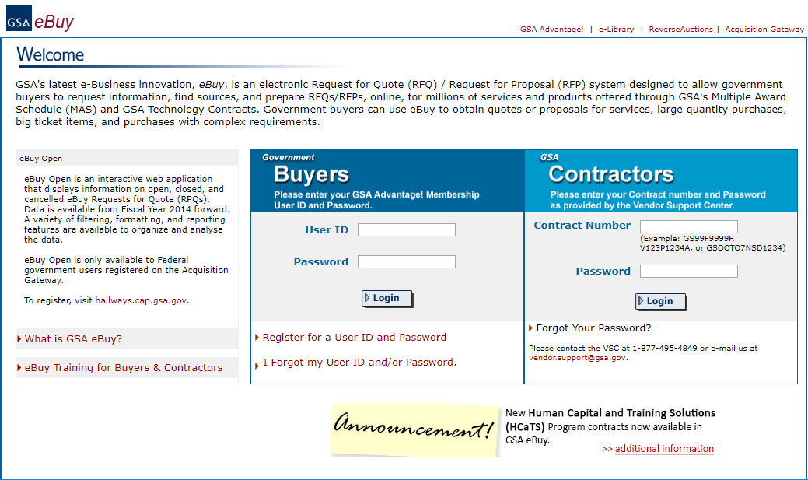GSA's eBuy is designed to facilitate requests and submissions of proposals for commercial products, services, and solutions offered through GSA for contracts such as Federal Supply Schedules and Governmentwide Acquisition Contracts (GWACs). Federal Purchasers (buyers) may prepare and post an RFP for specific CS3 products and services for a specified period of time. Once posted, CS3 contractors (sellers) may review the request and post a response.

eBuy is a simple, user-friendly, web-based online procurement tool to use for CS3 buyers. **First**, find a category and then select contractors to notify. All contractors listed under the category selected can also review or bid on your request.

**Second,** enter your requirements and specify the amount of time the RFP should remain open. Contractors will receive emails about your requirements and be able to submit proposals in return. See[eBuy web page](https://www.ebuy.gsa.gov/advantage/ebuy/start_page.do) or [eBuy training for buyers and contractors](https://www.ebuy.gsa.gov/advantage/main/ebuy_tutorial.do).

# APPENDICES

# Appendix A. Task Order Administration

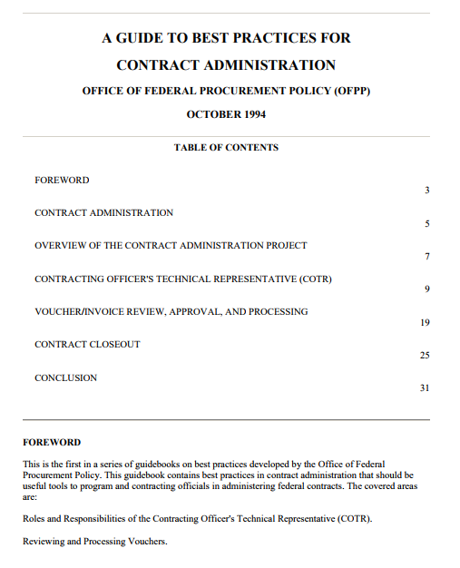Administration considers the following efforts to be associated with the operations and management of task orders post-award: service implementation, task order modifications, contractor performance management, and task order close-out.

As mentioned above the OCO for each task order will be responsible for closing out the order when completed. It is the responsibility of the CS3 contractors to work in partnership with the government to closeout orders as soon as possible by using procedures described in FAR 4.804. Notification of a completion of closeout of a task order must be provided to the GSA CS3 PCO immediately upon closeout.

## 1.1 User Reporting Requirements

### 1.1.1 Contractor Performance

Ordering agencies must periodically evaluate how the contractor performed in accordance with contract requirements such as the following:

* quality of service
* cost efficiencies
* timeliness
* business relations
* history of reasonable and cooperative behavior
* commitment to customer satisfaction
* key personnel

Ordering agencies should use the Past Performance Information Retrieval System (PPIRS) at <http://www.ppirs.gov/default.htm>.

Information obtained per evaluations may be shared with government agencies for use in support of future award decisions (FAR 42.15).

The customer agency is required by FAR 42.1502 policy to complete past performance records for the contractor. Customer agencies may already have established routinely utilized past performance systems (e.g., CPARS, FAPIIS, CPAS, PPIRS, etc.) these are all acceptable. From time-to-time, the GSA CS3 PCO may inquire about contractor performance by survey or telephone call.

## 1.2 Claiming Socioeconomic Credit in the Federal Procurement Data System – FPDS NG Reporting

Ordering agencies are required to report all orders greater than the micropurchase threshold in FPDS-NG, www.fpds.gov in accordance with FAR 4.6. Proper reporting ensures socioeconomic credit will be received. For assistance on coding, please contact the FPDS-NG Helpdesk via email: [fpdssupport@gcefederal.com](mailto:fpdssupport@gcefederal.com).

## 1.3 Contract Modification

Contract modification to the basic CS3 contracts may be required over the course of the CS3 period of performance. Contract modifications may take the form of a strategic modification or a contractor modification. A strategic modification is one that is made to all CS3 contracts; an example could be a modification that adds new technology to the CS3 contract. On the other hand, a contractor modification is geared towards a specific CS3 contract, and such an example would include a modification to recognize a contractor’s change of name. Each CS3 contractor is responsible for maintaining the CS3 contract on its public website that reflects all basic CS3 contract modifications. Additionally, it should be noted the contractor can and may post each contract modification separately.

Task order modifications may be necessary during the task order period to address additional requirements or administrative changes. The OCO should follow the FAR and guidance of their Agency-specific FAR supplement and other guidance.

## 1.4 Task Order (Contract) Closeout

It is the OCO’s responsibility to closeout task orders, and such closeout shall be accomplished within the guidelines set forth in:

* FAR Part 4.8 Government Contract Files.
* FAR Part 42 Contract Administration and Audit Services.
* GSAM Subpart 504.8 Government Contract Files.

The contractor agrees to cooperate with the OCO to close out task orders after expiration, cancellation, or termination.

# Appendix B. GSA CS3 Point of Contacts

**Note:** All members of the GSA CS3 team can be contacted at [CS3@gsa.gov](mailto:CS3@gsa.gov)

**GSA Program Manager (PM):**

Ben Camerlin

CS3 Program Manager

Office of Telecommunications Services

[Office of Information Technology Category (ITC)](http://www.gsa.gov/portal/content/105150)

[Federal Acquisition Service (FAS)](http://www.gsa.gov/portal/content/105080)

[U.S. General Services Administration (GSA)](http://www.gsa.gov/)

(W) [202-969-7790](tel:(202)%20969-7790)

(C) [202-341-3126](tel:(202)%20341-3126)

[benjamin.camerlin@gsa.gov](mailto:benjamin.camerlin@gsa.gov)

[www.gsa.gov/satellite](http://www.gsa.gov/satellite)

**GSA Procuring Contracting Officer (PCO):**

Tracey Embry

CS3 Procuring Contracting Officer

Network Services Contract Operations Division 2 (QT2A1FA)

[Office of Information Technology Category (ITC)](http://www.gsa.gov/portal/content/105150)

[Federal Acquisition Service (FAS)](http://www.gsa.gov/portal/content/105080)

[U.S. General Services Administration (GSA)](http://www.gsa.gov/)

(W) 703-306-7041

(C) 571-882-4104

[Tracey.embry@gsa.gov](mailto:Tracey.embry@gsa.gov)

[www.gsa.gov/satellite](http://www.gsa.gov/satellite)

**GSA Contracting Officer’s Representatives (CORs):**

**Primary**

Monica Hedgspeth

CS3 Contracting Officer’s Representative

Office of Telecommunications Services

[Office of Information Technology Category (ITC)](http://www.gsa.gov/portal/content/105150)

[Federal Acquisition Service (FAS)](http://www.gsa.gov/portal/content/105080)

[U.S. General Services Administration (GSA)](http://www.gsa.gov/)

(W) 703-306-6350

(C) 703-994-3254

[Monica.hedgspeth@gsa.gov](mailto:Monica.hedgspeth@gsa.gov)

**Alternate**

Scott Stemmen

CS3 Contracting Officer’s Representative

Office of Telecommunications Services

[Office of Information Technology Category (ITC)](http://www.gsa.gov/portal/content/105150)

[Federal Acquisition Service (FAS)](http://www.gsa.gov/portal/content/105080)

[U.S. General Services Administration (GSA)](http://www.gsa.gov/)

(W) 312-886-8276

(C) 312-384-0841

[Scott.stemmen@gsa.gov](mailto:Scott.stemmen@gsa.gov)

[www.gsa.gov/satellite](http://www.gsa.gov/satellite)

# Appendix C. List of CS3 Contractors

| Contractor | Contract Number | Contact | Small Business Category |
| --- | --- | --- | --- |
| [AIS Engineering, Inc.](http://www.aisengineering.com/CS3.html) | GS00Q17NRD4001 | [cs3@aisengineering.com](mailto:CS3@aisengineering.com) | SDB; WOSB |
| [Artel, LLC](https://www.artelllc.com/contract-vehicles/) | GS00Q17NRD4002 | [cs3@artelllc.com](mailto:CS3@artelllc.com) |  |
| [By Light Professional IT Services LLC](http://www.bylight.com/) | GS00Q17NRD4003 | [cs3@bylight.com](mailto:cs3@bylight.com) |  |
| [Comsat Inc.](http://www.comsat.com/contractvehicles/) | GS00Q17NRD4004 | [cs3@comsat.com](mailto:CS3@comsat.com) |  |
| [CopaSAT, LLC](https://boozallen.sharepoint.com/teams/gsa/Shared%20Documents/CS3/Ordering%20Guide/CopaSat,%20LLC) | GS00Q17NRD4005 | [cs3@copasat.com](mailto:CS3@copasat.com) | SB |
| [DRS Global Enterprise Solutions](http://www.leonardodrs.com/about-us/contract-vehicles/gwac-idiq/fcsa/) | GS00Q17NRD4006 | [drs-fcsa@drs.com](mailto:DRS-FCSA@drs.com) |  |
| [Globecomm Systems Inc.](http://www.globecomm.com/) | 47QTCE18D0001 | [cs3@globecomm.com](mailto:CS3@globecomm.com) |  |
| [Hughes Network Systems, LLC](https://government.hughes.com/how-to-buy/federal-contracts/gsa-cs3) | GS00Q17NRD4007 | [cs3@hughes.com](mailto:CS3@hughes.com) |  |
| [Incident Communication Solutions, LLC (d/b/a Peake)](http://peake.com/working-with-peake/contract-vehicles/cs3/) | GS00Q17NRD4008 | [cs3@peake.com](mailto:CS3@peake.com) | SDB |
| [Inmarsat Government, Inc.](https://www.inmarsatgov.com/contracts/contract-vehicles/) | GS00Q17NRD4014 | [fcsapmo@inmarsatgov.com](mailto:FCSAPMO@inmarsatgov.com) |  |
| [Intelsat General Corporation](http://www.intelsatgeneral.com/contracts/) | GS00Q17NRD4009 | [cs3@intelsatgeneral.com](mailto:CS3@intelsatgeneral.com) |  |
| [Knight Sky LLC](http://www.knight-sky.com/cs3.html) | GS00Q17NRD4010 | [cs3@knight-sky.com](mailto:CS3@knight-sky.com) | SB |
| [LBiSat LLC](http://www.lbisat.com/government.html) | GS00Q17NRD4011 | [gsacs3@lbisat.com](mailto:gsacs3@lbisat.com) | SB |
| [Lepton Global Solutions, LLC](http://leptonglobal.com/about-us/contract-vehicles/) | GS00Q17NRD4012 | [cs3@leptonglobal.com](mailto:CS3@leptonglobal.com) | SB |
| [RiteNet Corp](http://www.ritenet.com/html/contract_vehicles.html) | GS00Q17NRD4013 | [cs3@ritenet.com](mailto:CS3@ritenet.com) | SB |
| [SES Government Solutions, Inc.](http://ses-gs.com/contract-vehicles/) | GS00Q17NRD4015 | [ses-gscs3@ses-gs.com](mailto:ses-gscs3@ses-gs.com) |  |
| [Signal Mountain Networks, Inc.](https://www.signalmountain.com/contractvehicles) | GS00Q17NRD4020 | [cs3@signalmountain.com](mailto:cs3@signalmountain.com) | VOSB; HUBZone |
| [TeleCommunication Systems Inc.](http://www.telecomsys.com/about/contract-vehicles/default.aspx) | GS00Q17NRD4016 | [cs3tor@comtechtel.com](mailto:cs3tor@comtechtel.com) |  |
| [Trace Systems, Inc.](https://www.tracesystems.com/contracts/) | GS00Q17NRD4017 | [idiq-inbox@tracesystems.com](mailto:Idiq-inbox@tracesystems.com) |  |
| [TrustComm, Inc.](http://www.trustcomm.com/cs3/) | GS00Q17NRD4018 | [cs3@trustcomm.com](mailto:CS3@trustcomm.com) | SB |
| [UltiSat, Inc.](http://www.ultisat.com/custom-satellite-communications-solutions-cs3) | GS00Q17NRD4019 | [fcsa@speedcastgov.com](mailto:fcsa@speedcastgov.com) |  |
| [U.S. Electrodynamics, Inc.](https://www.usei-teleport.com/) | 47QTCE18D0002 | [sales@usei-teleport.com](mailto:sales@usei-teleport.com) | SDVOSB, VOSB, SDB |

# Appendix D. List of Abbreviations

ACO Administrative Contracting Officer

CLINs Contract Line Item Numbers

COMSATCOM Commercial Satellite Communications

COR Contracting Officer’s Representative

CPARS Contractor Performance Assessment Reports System

CPAS Contractor Performance Assessment Reports System

CS2 Custom SATCOM Solutions

CS2-SB Custom SATCOM Solutions – Small Business

CS3 Complex Commercial SATCOM Solutions

DISA Defense Information Systems Agency

DPA Delegation of Procurement Authority

FAPIIS Federal Awardee Performance and Integrity Information System

FAR Federal Acquisition Regulation

FISMA Federal Information Security Management Act

FPDS- NG Federal Procurement Data System Next Generation

FTR Federal Travel Regulations

GASM General Services Administration Acquisition Manual

GSA General Services Administration

GWAC Government Wide Acquisition Contract

HSPD-12 Homeland Security Presidential Directive 12

IA Interagency Agreement

IAW In accordance with

IPAC Intra-Governmental Payment and Collection

JTR Joint Travel Regulations

MIPR Military Interdepartmental Purchase Request

MOA Memorandum of Agreement

MOU Memorandum of Understanding

OCOs Ordering Contracting Officers

OTS Office of Telecommunications Services (OTS)

PCO Procuring Contracting Officer

PPIRS Performance Information Retrieval System

PM Program Manager

PoP Period of Performance

PR Purchase Request

PWS Performance Work Statement

RFI Request for Information

RFP Request for Proposal

SATCOM Satellite Communications

SIM Subscriber Identity Module

SOW Statement of Work

1. GSA recognizes that satellite technologies and services are rapidly evolving. Accordingly, GSA anticipates that services and solutions available under CS3 will be increased, enhanced, and upgraded so that technological and serviced-based improvements become available to COMSATCOM customers.